**REPORT ON PATIENT HEALTH METRICS**

1. **Introduction**

The aim of this analysis is to explore patient health metrics to identify key risk factors associated with conditions like diabetes, high blood pressure, and cholesterol issues. By examining data across various parameters such as age, BMI, blood pressure, cholesterol levels, and exercise rates, we can gain valuable insights into the overall health trends of the patient population. This analysis will inform recommendations for improving patient outcomes and managing health risks more effectively.

1. **Data Processing:**

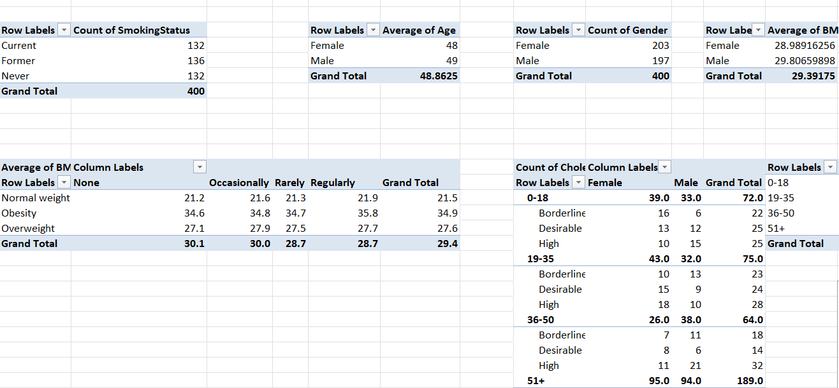

**Data Cleaning:**

* + Checked for and addressed missing or inconsistent data entries and also removed duplicates.
  + Ensured accurate classification of variables like cholesterol levels and BMI.

**Feature Engineering:**

* + Created Age Bracket to group patients into meaningful age categories.
  + Combined systolic and diastolic blood pressure into a single string format (e.g., 120/80).
  + Created a Month-Year column for easier time-based analysis.

**Data Aggregation:**

* + Grouped data by Age Bracket, Gender, and other categorical variables to analyze distribution patterns.
  + Generated counts and averages for key metrics to identify trends.

1. **Visualization**

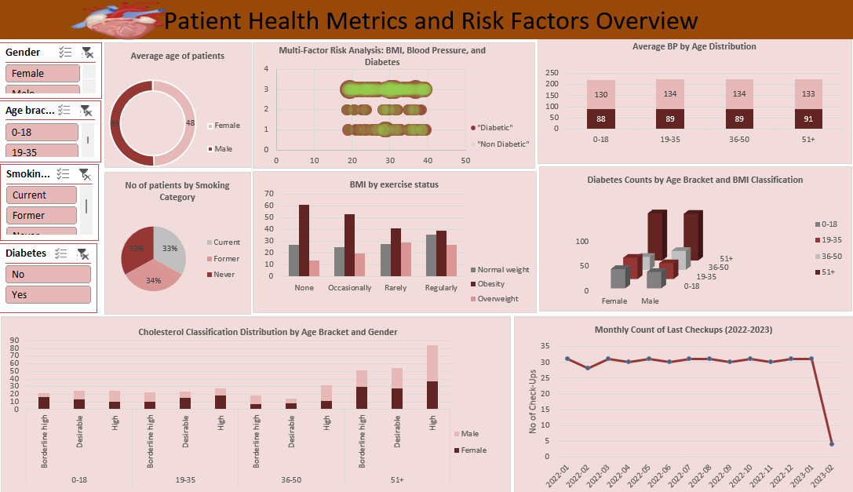

1. **Insights and Recommendations**

**Age and Health Risk Distribution:**

* + **Insight:** Higher incidence of diabetes and high cholesterol levels were observed in older age brackets (51+). Younger age groups (below 30) showed a higher prevalence of normal cholesterol and BMI levels.
  + **Recommendation:** Focus on preventive care and early intervention strategies for older adults to manage blood pressure and cholesterol.

**Gender Differences:**

* + **Insight:** Males showed a slightly higher tendency towards elevated blood pressure and cholesterol levels compared to females, especially in middle-aged groups(for blood pressure) and older age brackets(for cholesterol).
  + **Recommendation:** Tailored health programs targeting lifestyle changes in males could help mitigate these risks.

**Correlation Between BMI and Diabetes:**

* + **Insight:** A strong positive correlation was found between higher BMI and the likelihood of having diabetes, with obese individuals showing the highest risk.
  + **Recommendation:** Promote weight management programs and regular health check-ups for individuals with high BMI to reduce the risk of diabetes.

**Cholesterol Classification Across Age and Gender:**

* + **Insight:** Cholesterol levels tended to rise with age, with a higher proportion of high cholesterol cases found in males over 50.
  + **Recommendation:** Implement regular cholesterol screening, especially for males in higher age brackets, and encourage dietary adjustments to manage cholesterol levels.

**Exercise Rate and Health Outcomes:**

* + **Insight:** Patients with higher exercise rates generally exhibited healthier BMI and cholesterol levels, underscoring the importance of regular physical activity.
  + **Recommendation:** Encourage consistent exercise routines through community health programs and personalized fitness plans.

1. **Conclusion**

The analysis of patient health metrics reveals critical insights into how age, gender, BMI, and lifestyle factors like exercise influence key health outcomes, particularly concerning diabetes and cardiovascular risk. The findings suggest that targeted interventions focusing on weight management, regular exercise, and age-specific health monitoring can significantly improve patient health outcomes. Future efforts should concentrate on implementing these recommendations in clinical practice, along with ongoing data monitoring to evaluate the effectiveness of these interventions.